

**Planning Statement - 05/03/2019**

*Introduction:*

This statement has been prepared to support an application by Cringleford Tennis Club for additional floodlights on existing outdoor tennis courts situated on the recreation ground in Oakfields Rd, Cringleford, NR4 6XF.

This statement also addresses the requirements of a design & access statement.

*Proposal:*

To provide a new perimeter lit floodlighting scheme to existing outdoor tennis courts suitable for club level tennis at the same time minimizing the light spill and glare to nearby properties and the environment.

*Application Site & location:*

The tennis courts form part of the amenities within the Oakfields Rd recreation park which is owned and managed by Cringleford Parish Council. The site is situated off Oakfields Rd immediately adjacent to cricket and football pitches. The exact location is shown on the site and location plan attached to the planning application.

The tennis club is a long established entity in the village and has a history going back many years.

*Background:*

Cringleford Tennis Club – a not for profit organisation – lease the tennis court site from the Parish Council and are responsible for the construction, maintenance and running of the facility. There are currently four all weather courts and two grass courts; the two lower all weather courts were floodlit in 2008 and the floodlights have been in regular use since that time.

The club is run by a committee of volunteers who give their time freely to promote and manage the facility. The courts are in very good condition with all four of the all weather courts having been resurfaced in recent years at the clubs expense.

Club membership is now running at around 170 members and we have more members wishing to play than the current floodlight court capacity allows. Play is constrained to a maximum of eight outside of daylight hours as there are only two floodlight courts. Many of our members work during the day and are only able to play tennis outside of normal working hours which has made our evening sessions increasingly popular. The club also enters a number of teams in local leagues with matches being played in the evenings on our courts which has led to further pressure on floodlight capacity. Numbers are such that the two extra floodlight courts would enable more members to continue to play tennis all year round. The restriction of only two floodlight courts is a factor in the ability of the club to attract and retain members, which is required to ensure long term viability.

The club has the necessary funds through judicious management to finance the proposed floodlighting scheme in its entirety and assuming planning consent is forthcoming propose to carry out the installation later this year, having previously tendered the works and appointed a specialist contractor to carry out the scheme.

*Layout:*

The proposal is to install four 10m high new galvanised steel columns, these will be located in line with the court baselines in a similar position to the floodlight locations on the bottom courts (see diagram in the lighting design document and photograph below) .

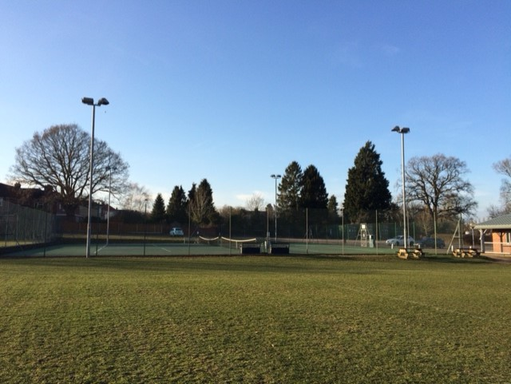*Existing floodlights on bottom courts*

*Technical Details:*

The scheme utilises two LED low energy fittings per column; LED floodlights are known for being super-efficient. For example, a 100W LED floodlight beams 115 lumens per Watt consumed. Metal halide lights (which we have on our existing courts) require 200 Watts for the same light output. These lamps are also known for their long life of up to 30,000 hours whereas currently we are replacing one bulb per year on our existing installation.

The lights proposed are a new range of high performance lamps noting that the “superior optics of the Hilux Ace LED luminaire have been specifically selected to minimize the effects of nuisance overspill to adjacent dwellings”. Our proposed installer Luminance Pro have provided a comprehensive lighting design which is attached to the application. The lighting will be controlled from a new feeder pillar located adjacent to the existing entrance gate on the top courts and of similar size to that on the bottom courts (see photograph below). The lighting mechanism will incorporate a time clock in order that the hours of operation can be controlled - we would anticipate hours of operation being similar to the existing floodlights which are not used before 8.00 in the morning or after 10.00 in the evening.

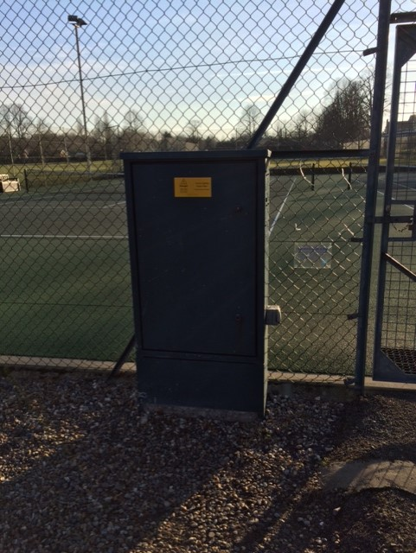

*Existing feeder pillar*

*Good neighbour policy:*

The club have good relations with residential neighbours and wish these to continue. The use of LED lighting ensures the most effective light control whilst providing appropriate light levels. The lighting design prepared by Luminance Pro includes a Google aerial photo of the site on to which is superimposed the light overspill Iso Contours (the light contour plot shows a computer prediction of the Lux level values at ground level, in simple terms how bright at ground level). This demonstrates that the surface illuminance lux level with the floodlights on has reduced to less than five before reaching any residential properties. By way of comparison the lux level from a streetlight is 25 lux.

Residential neighbours who may find the floodlights visible have been consulted (see leaflet attached as Appendix) - these are the properties as set out below:

Keswick Close - No’s 20,41,39,37 & 35

Mark Lemmon Close - No’s 6,7,8,9,10,11,12,13,14,15 & 16

Oakfields Rd - No’s 20, 22, 24, 26, 28, 23, 25, 27, 29, 31 & 33

*Access:*

The existing access to the Pavilion and Playing Fields will remain unchanged. The car parking provision is controlled by the Parish Council and the proposal will not have any effect on peak parking numbers during the day/weekends.

*National Strategy:*

The cross-government strategy outlined in the policy paper “Sporting Future – (A new strategy for an active nation)’’ is to “tackle head on the flat lining levels of sports participation and high levels of inactivity in this country” and to ensure that “people of all ages and backgrounds can enjoy the many benefits that sport and physical activity bring, at every stage of their lives”.

Paragraph 96 of the National Planning Policy Framework – July 2018 reaffirms this in stating that “access to.....and opportunities for sport and physical activity is important for the health and wellbeing of communities”.

**C:\Users\Chris\Desktop\Cringleford Tennis - Logo - Print Ready - 070814 small.tifAppendix**

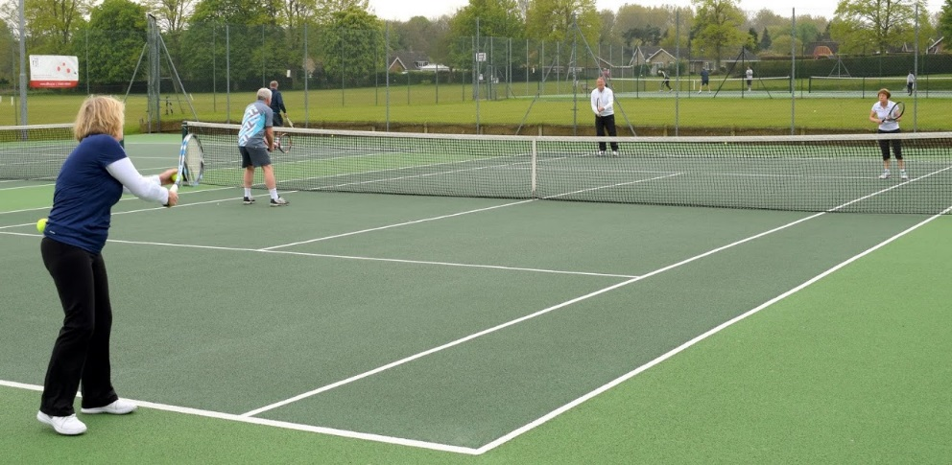

Cringleford Tennis Club will shortly be making a planning application to South Norfolk District Council to have floodlights installed on the top two hard courts adjacent to Oakfields Road.

The club propose to install LED lights which are very energy efficient and minimise light spillage. Operating hours will be the same as the existing floodlights preventing use before 8am and after 10pm.

If you go to our website [www.cringlefordtennis.net](http://www.cringlefordtennis.net) and click on ‘Club Info’ you will find further details including our Lighting Design and our Planning Statement. We thought you would appreciate being advised about these proposals before they were formally submitted.

If you have any queries or wish to discuss please contact Chair, Chris Mitchell on 01603 457288 or email chrismitchell32@sky.com.